Project Name – Incredible India

Java Script

In header and footer mouseover() function is used to point out menu.

**Header**



**Footer**

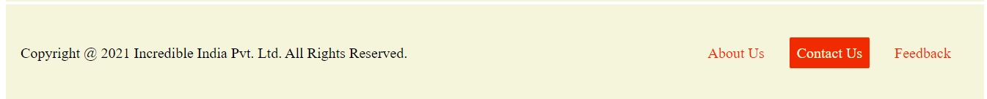

Also java script is used in index.html for automatic slideshow. (Image changes every 2 seconds)

**Slideshow**



In Travel Guide page mouseover() function is used. (Opacity of the image decreases on mouseover)

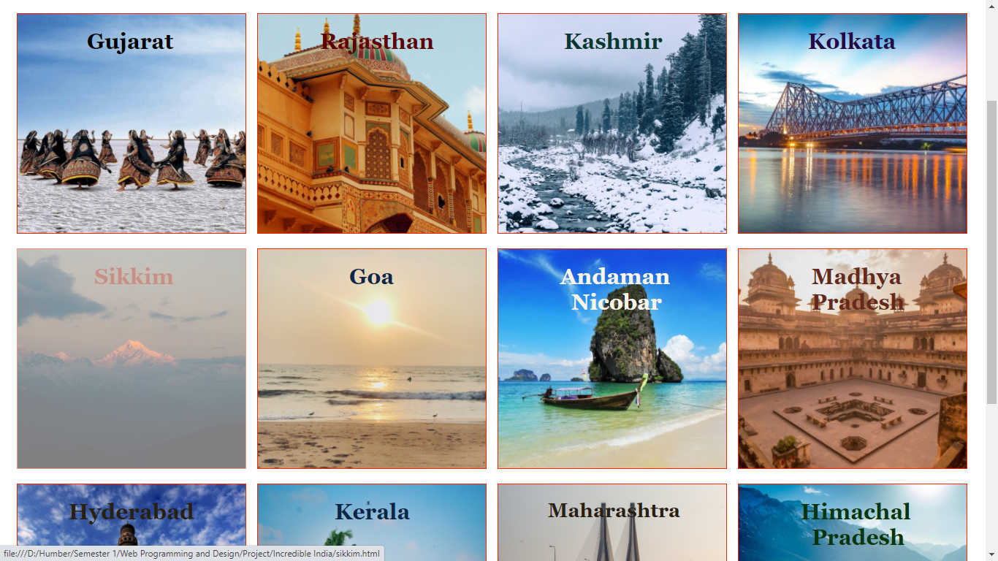

Here, the mouse is pointed at Sikkim so the image is light (little transparent).

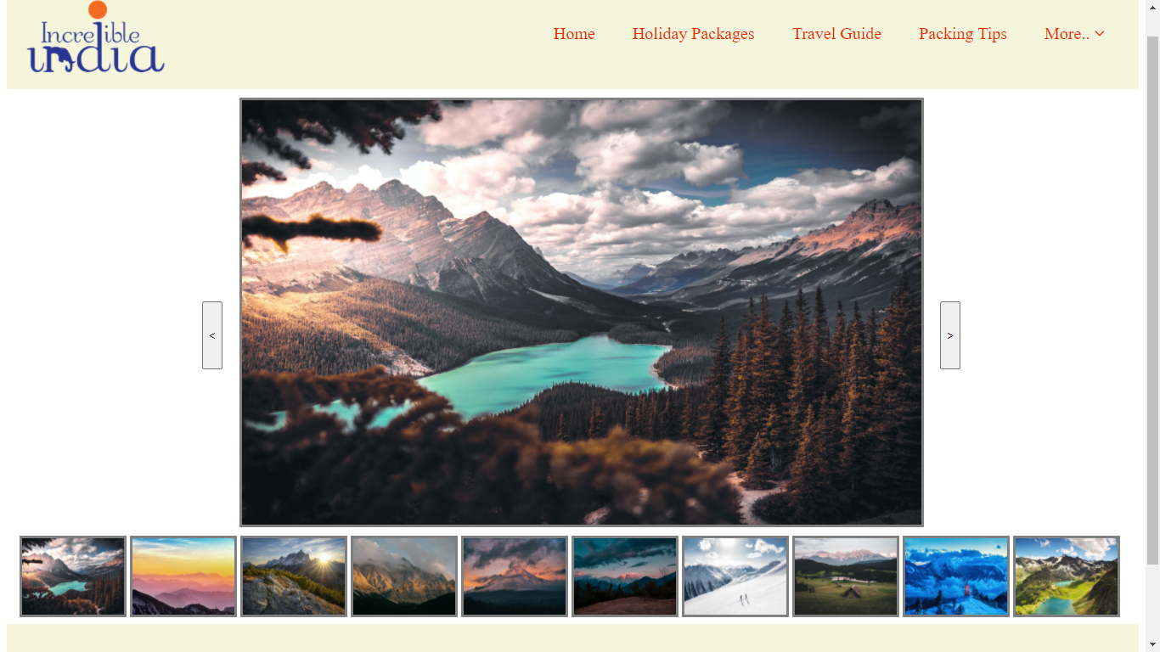

Lastly java script is utilized in slide.html to traverse through images using left and right arrow buttons as well as using onclick function.